Muhammed kallo 220201916
Sudenaz Kılıç 220201054
Gülbahar Yalçındağ 220201001
Nisa Sert 220201029

MLRP-KG: Mine Landslide Risk Prediction Based on Knowledge Graph

1. We propose a new mine landslide risk prediction model using knowledge graph

In this study, a Knowledge Graph (KG)-based model is proposed to predict landslide risk. Firstly, data from past mine slopes were used to construct a knowledge graph. In this graph, each slope is represented as an entity (node), while the similarity relationships between slopes are defined as relations (edges) (e.g., similar and dissimilar).

Then, a translation-based embedding model was employed to represent the nodes and relations of the knowledge graph in a vector space. This allows the similarity between a new slope and past slopes to be calculated. The model evaluates how closely the new slope resembles slopes that have experienced landslides and how different it is from stable slopes, producing a risk value accordingly.

Finally, the landslide risk is calculated using the Landslide Matching Rate (LMR) metric.

LMR = (L_s + S_d) / (2 × NS)

In this formula, the similarity of the new slope to past landslide slopes and its difference from stable slopes are considered to obtain a risk ratio, which is then used to predict the landslide risk for the slope.

2. Gradient Boosting Decision Tree

Gradient Boosting Decision Tree (GBDT) is a machine learning method that combines multiple decision tree models sequentially to improve prediction accuracy. In this approach, each new tree learns from the errors of previous models, aiming to reduce these errors. This step-by-step refinement results in more accurate predictions.

In this study, the GBDT algorithm was used to classify and predict landslide risk based on the extracted features.

3. Crossed Features

Crossed Features, or “feature interactions,” involve combining two or more features to create a new feature. The purpose is to capture stronger and more meaningful relationships that individual features alone may not fully represent.

Some features that may be considered for predicting landslide risk include:

Slope angle (Slope Angle)

Soil type (Soil Type)

Rainfall amount (Rainfall)

Individually, Slope Angle or Rainfall may not provide complete information about risk. However, when evaluated together:

High slope + heavy rainfall → higher risk

Low slope + heavy rainfall → lower risk

This is where crossed features come into play. The model uses these combined features to provide more accurate landslide risk predictions.

4. Use of Semantic Network via Knowledge Graph

In the study, the Landslide Semantic Network was constructed using a knowledge graph, which functions as follows in landslide risk prediction:

Nodes (Entities):
Data from past slopes are represented as individual nodes.

Example:
Slope_A, Slope_B, Slope_C

Edges (Relations):
Relationships between slopes (similarity or dissimilarity) are represented as edges.

Example:
Slope_A → Slope_B (similar)
Slope_A → Slope_C (dissimilar)

Translation-based Embedding:
Nodes and relations in the knowledge graph are represented in a vector space.

This allows the model to compute similarities and differences between a new slope and past slopes.

Risk Prediction:
When a new slope is evaluated, the semantic network compares it with past slopes.
The slope’s similarity to landslide-affected slopes and its difference from stable slopes are calculated, and a risk value is generated using the Landslide Matching Rate (LMR).

Summary:
The knowledge graph is used to construct the semantic network and visualize relationships.

The semantic network prevents the model from relying solely on individual features and allows it to account for relationships between slopes, resulting in more accurate landslide risk predictions.

Code :
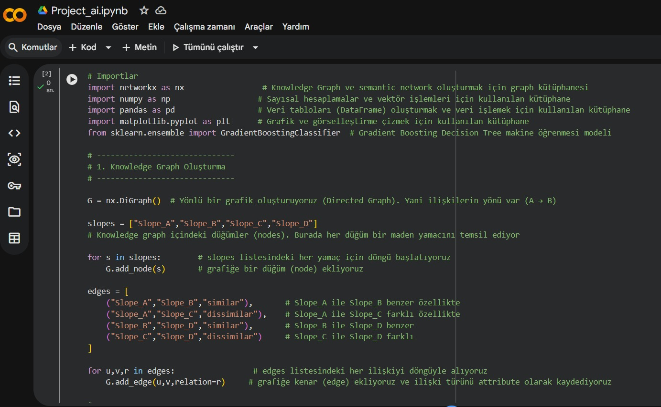

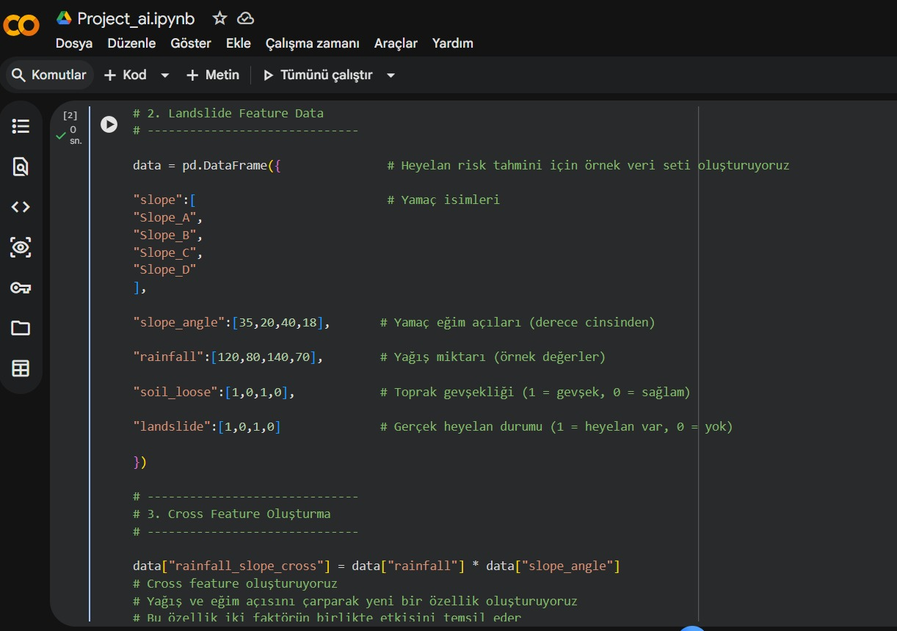

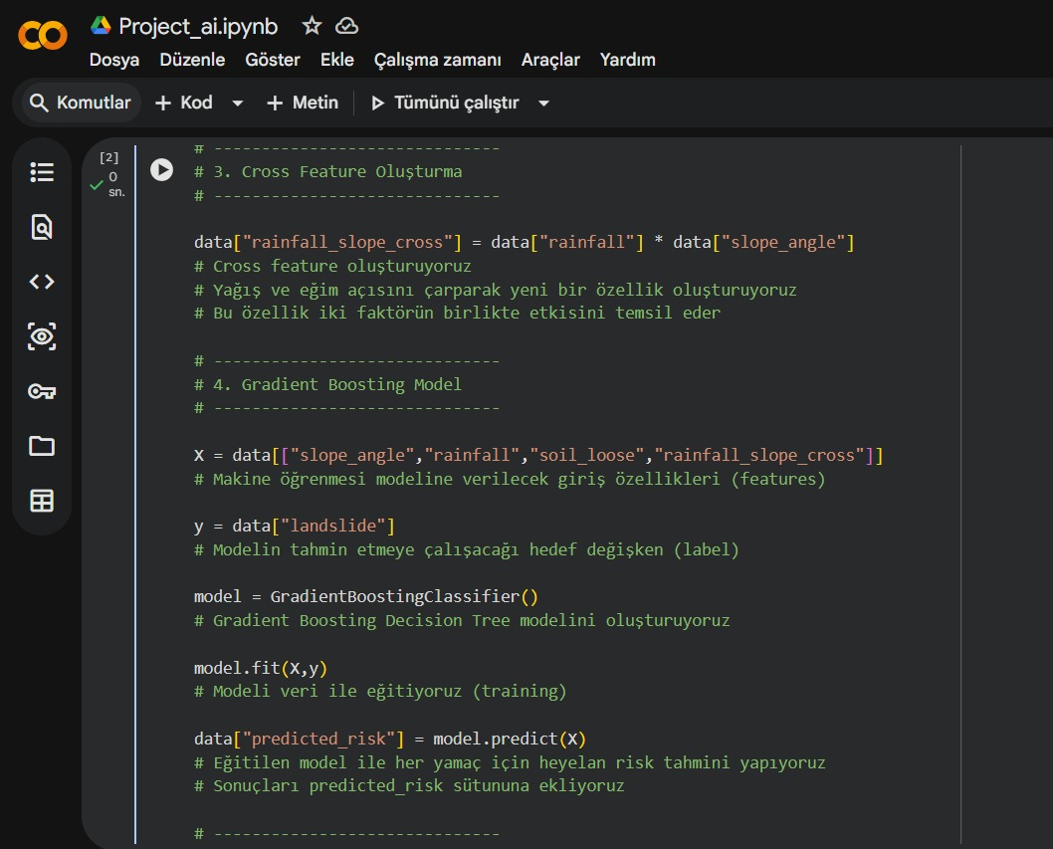

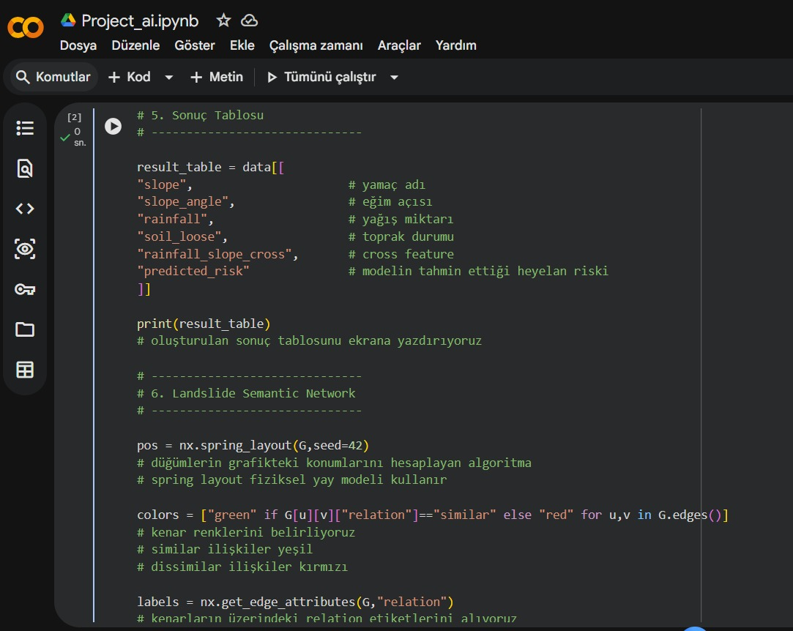

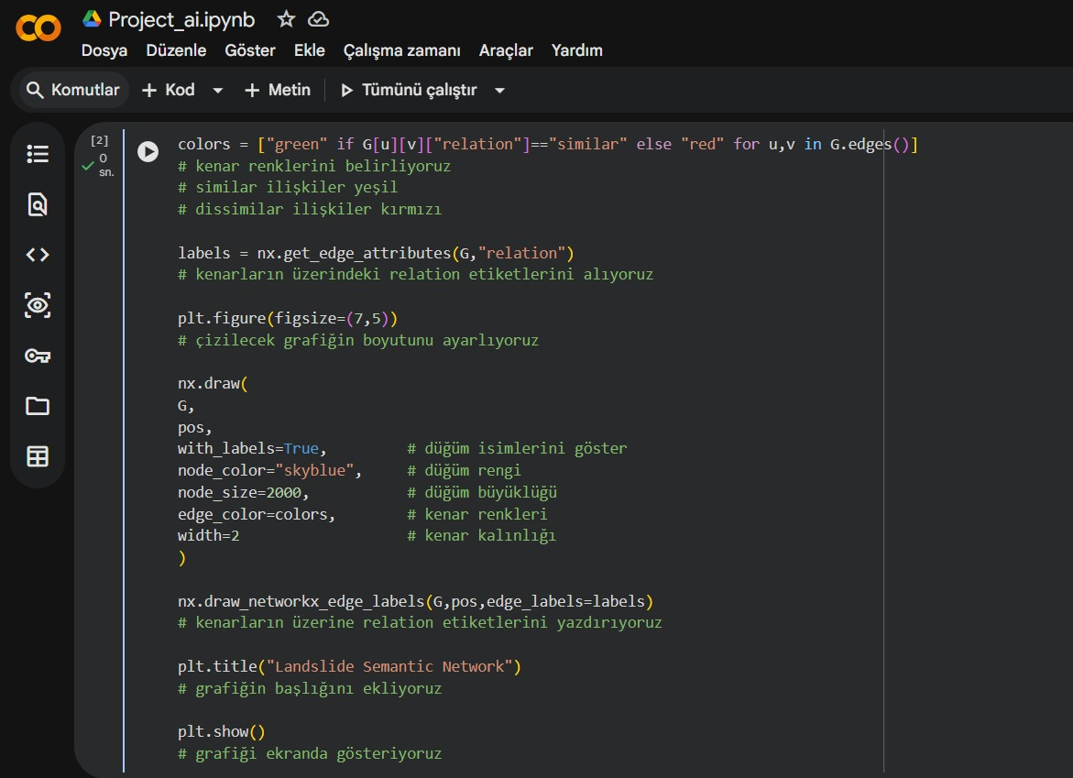

Result:

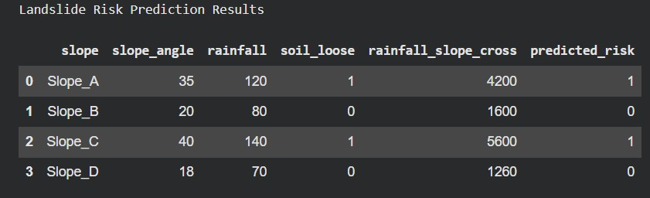

Graph :
